**Instructions for filing “motion to intervene” in Notice of Penalty 19-4-000**

**Background:**

* On January 25, 2019, the North American Electric Reliability Corporation (NERC) filed a Notice of Penalty with FERC that disclosed 127 cybersecurity standard violations by unidentified “Companies.”1 NERC and its Regional Entities (RE) determined: *[T]he 127 violations collectively posed a serious risk to the security and reliability of the BPS (Bulk Power System). The Companies’ violations of the CIP Reliability Standards posed a higher risk to the reliability of the BPS because many of the violations involved long durations, multiple instances of noncompliance, and repeated failures to implement physical and cyber security protection.*
* In keeping with FERC’s tradition since 2010 to not disclose the identity of companies violating safety and security standards, FERC has not named the penalized company, though media sources have disclosed that it is Duke Energy.
* Michael Mabee, author of the Civil Defense Book, and member of the Secure The Grid Coalition, has filed a motion to intervene in this docket, calling for FERC to not only name this company but the others that have been un-named since 2010. Another motion was filed by “Public Citizen.” Both examples are attached.
* Regardless of the media citing the name of the entity as Duke Energy, it is up to FERC to decide whether it will continue its tradition of “covering” for utility industries by keeping their identities hidden from public scrutiny. We can affect FERC’s decision if we gather and submit as many motions to intervene as possible before the deadline. We should also encourage others to file such motions prior to the deadline of 29 March 2019. (Be sure to file them on the 28th to make sure they are processed)

**log in**  **https://www.ferc.gov/docs-filing/eregistration.asp?csrt=9556442548254249104**

Go to FERC’s website: <https://www.ferc.gov/>

* Hover over the “Documents & Filings” section
* Go to “E-Register” and register yourself by following the intuitive step by step process that includes an email verification and an assignment of a FERC ID number.
* Draft a letter using the exact formatting below.
* In the first paragraph you should tell the Commission what action you are requesting, e.g., I request that the Commission release the unredacted Notice of Penalty and Settlement Agreement - including the names of the violators - into the public docket.
* Save this letter as a PDF with your signature.
* Use this format/header for your letter

---------------------------

**UNITED STATES OF AMERICA**

**BEFORE THE**

**FEDERAL ENERGY REGULATORY COMMISSION**

**NERC Full Notice of Penalty regarding )**

**[Redacted in Public Version of NOP] ) Docket No. NP19‐4‐000**

**)**

**MOTION TO INTERVENE**

Submitted to FERC on _____Date_____

__ Your Name___, a private citizen, requests the Commission’s leave to intervene in the above captioned docket, pursuant to 18 C.F.R. § 39.7(e)(4). I request that 1) the Commission review this Notice of Penalty (NOP) to ensure that it is in the public interest, and 2) that the name of the entities(s), the unredacted Notice of Penalty and the unredacted settlement agreement be released in the public docket. NERC has made redactions to the publicly available documents, alleging the identities and other identifying information about Critical Infrastructure Protection (CIP) standards violators must be kept from the public. The lack of transparency in this Notice of Penalty raise significant public interest concerns.

[Continue your justification that these companies are endangering our families and NERC and FERC are covering up their identities. We have a right to know who is endangering us. If “secret regulation” was going to work, it would have worked by now - the Russians have been in the electric grid for over a decade.]

---------------------------

* Go back to the FERC website and go to the FERC Online section
  + <https://www.ferc.gov/docs-filing/ferconline.asp>
  + Login with your credentials
  + Click on “eFiling”
  + Go to: General —> Intervention —> Motion to Intervene
    - On the next screen enter docket number: NP19-4. Then follow the prompts to upload your document.
  + Attach the PDF (Filing is free.)
  + See screenshots below:

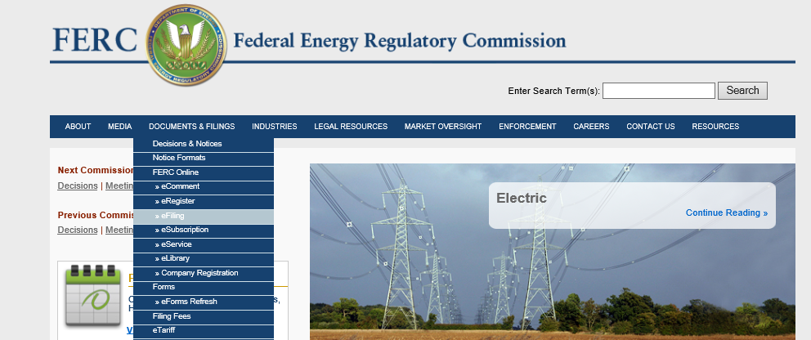

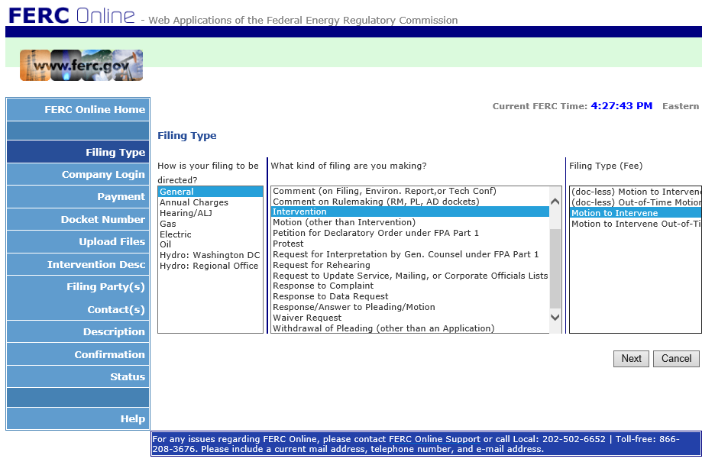

* Send a copy of your letter to Tommy Waller at [twaller@securefreedom.org](mailto:twaller@securefreedom.org) so that Tommy can file copies for the Secure The Grid Coalition.
* If you are unfamiliar with the coalition, visit this website: <http://securethegrid.com/about-us/>

The links to the actual FERC Files are here:

1: (most important)

<https://elibrary.ferc.gov/idmws/common/downloadOpen.asp?downloadfile=20190125%2D5067%2833360624%29%2Epdf&folder=8296512&fileid=15147829&trial=1>

2: <https://elibrary.ferc.gov/idmws/common/downloadOpen.asp?downloadfile=20190125%2D5067%2833360625%29%2Epdf&folder=8296577&fileid=15147830&trial=1>

3:

<https://elibrary.ferc.gov/idmws/common/downloadOpen.asp?downloadfile=20190125%2D5067%2833360626%29%2Epdf&folder=8296607&fileid=15147831&trial=1>

4:

<https://elibrary.ferc.gov/idmws/common/downloadOpen.asp?downloadfile=20190125%2D5067%2833360627%29%2Epdf&folder=8296697&fileid=15147832&trial=1>